Specification for first FBA app version (1.0)

General requirements
- Take out all the seminars for now. It’s too complicated and having AI read them is questionable and something we’d need to negotiate with the literary executors.
- Focus with Bhante on talks and talk transcripts: easy to find, search, play.
- Integrate remastered versions and the toggle interface to listen to original versions. See:
Digital Legacy
Buddhism for Today – and Tomorrow
- All the FBA talks are actually already there (via search). We just need a simple way to surface them that doesn't break ease of use within the app. See Collections on home page.
- Must support existing FBA login to control access to Order-only talks
- Needs Join page with subscription info and in-app options
- Download should have a way to differentiate between downloaded talks and transcripts (only if transcripts can actually be downloaded separately - see question below).
- GUI interface: replace brown text with #000

Navigation bar:
Home | Search | Downloads | Donate | Join | My FBA
- Downloads only available after they join. Tapping takes you to join page.
- Move ‘Recently listened’ to MY FBA - see question below + add donate button here.

Home page
- Logo + Free Buddhist Audio + Log in / out
- Sangharakshita (image)
  - Year (text link > list with images)
  - Series (text link > list with images)
- Digital Legacy (support ask & button)
- Collections (image)
Curated collections lists: image for each collection within a page using auto-generated colour artwork (cf. Apple Music genres & AI playlists) unless there is an existing cover image (eg. some themes, series, places).
Selecting a collection opens a titled page listing talks with images similar to the search results interface.
Can non-English talks be filtered out at the top-level for collections (we can give specific markers - tags, catalogue prefixes to assist)? Can there be a setting to toggle that? English | All languages
  - Order talks (text link > list with images) - only visible if logged in with OM account
  - Introductions (text link > list with images)
  - Meditations (text link > list with images)
  - Latest (text link > list with images)
  - Themes (text link > list with images)
Use only named collections under the side menu – see separate page for direct links.
  - Series (text link > list with images)
  - People (text link > list with images)
  - Places (text link > list with images)
- Support FBA (button)
- Connect: fba podcast | dharmabytes podcast | youtube | facebook | instagram | soundcloud | tbco (logos only linked, see site)

Search
- All | Audio | Text | Speaker? (speaker functionality is currently unclear in the prototype app)
- Search should differentiate between audio and text results (text searching only available via subscription, if it still applies after we remove seminars)

Talk & Series Pages
- Series lists should support images (as talks currently do)
- Series pages should display blurbs (integrate from FBA site + Colin’s work?)
- Every talk and series page should have a donation button under ‘View transcript’ (talks) or under the blurb (series)

Notes and questions
- In order to access talks, we will need to switch to using the new FBA API (when it’s ready) before launch
- Does removing seminar transcripts mean no text results in the search (because transcripts of talks only appear under the talk page itself)? If so, are transcripts also downloaded and available when the user downloads a talk to the app?
- Do downloaded talks always play from the offline version of the file stored within the app, or only when you play it from the downloads section?
- It looks like the app has its own source data for ‘recently listened’. For users logged in online there already: https://www.freebuddhistaudio.com/my-profile/history Can these be integrated under My FBA? (Iteration?)
- At the moment the only transcripts of talks are those by Sangharakshita. Can we incorporate Colin’s work to bring in automated transcripts of all talks?
- Can we integrate Car Play and Android Auto?
- Will the app have its own analytics? Or are these served via the Google Play and Apple App Stores?
- Jay did work on a feature to build playlists of talks / tracks. That work would need finishing (including the ability to add tracks / talks on-the-fly to a playlist via search results, like YouTube). Something for a future iteration.
- A later version of the nav bar might incorporate into My FBA (existing account page and / or subscription page depending on subscription & business model - see below / playlist support in future)
- We need to make a lot of improvement at https://www.freebuddhistaudio.com/browse?cat=guided_introductions&t=audio: tagging tags with genres that collect titles on this page; ordering (possibly weeding), etc.
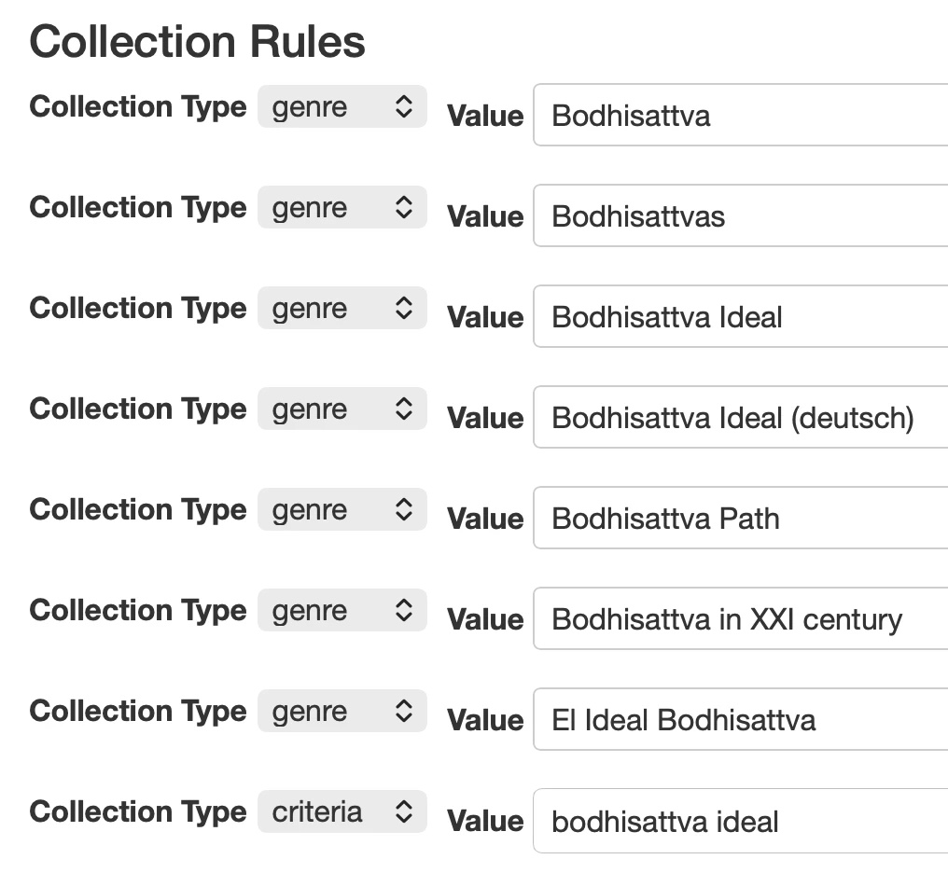
- We need to make a lot of improvement around themes | genres.
Genres is the old system data, based on tagging. Users uploading rarely tag accurately. We could apply AI to transcribe the whole catalogue and, once transcribed, generate major keyword lists for each talk (according to pre-set criteria) and add these into the genres database, bringing it back into greater relevance. Then we’d update the search engine with new weighting to reflect this.
Themes was our interim solution for the relaunch a few years ago, which is still worth integrating. It’s run off an admin tool that allows us to build very specific curated lists of talks by combining specific sets of search terms with specific existing genres.
So, for example, I could go to any one of each of these genres:
Bodhisattva | Bodhisattva Ideal.
Or I can go to the theme Bodhisattva Ideal, which contains the categories below and could be added to.

Launching the app and the business model
- Target launch date: Dec 6, 2026 - the 20th anniversary of FBA
- We need to investigate whether Apple and Google will charge us to link out to the web for donations. As a business they would according to the new rules for the EU, which will likely apply in the UK too. In the U.S. too under different terms, and in other places (e.g. Japan), also under different terms.
  - We can apply as a non-profit to accept donations via the Google Play / App Store payment systems, which should exclude us from having to track external donations generated via both OS and pay commission on those donations.
  - We currently accept Apple Pay and Google Pay on the web via Stripe. To avoid commission fees in-app we would likely have to switch to using the native OS donation solutions (hopefully with a similar exemption from commission). So we would stop linking out to the web.
  - The app will not be accepted for the Google Play or App Store without this being resolved.
- Do we remain entirely based on voluntary donations via link-out to the web donation page? Or do we charge for any aspect of access? e.g. It is free to use the app and listen but if you want to download you have to join as a paid subscriber. Or if you want to search the transcripts you have to join as a paid subscriber.
- Paid subscription would likely have to be a separate system (at least initially) from making donations via the web. It is likely (and probably preferable, in terms of admin) that we’d have to pay Apple / Google via in-app purchases for people who take out a monthly or annual subscription.
Later this could, in principle, be integrated into a site membership system that is by donation, but that would be complex (we’d need to restrict the same features on the web version). We could just keep the web as it is and make paid subscription membership an app thing only.
- Cost:
Monthly $9.99 | £7.49 | €8.75 | AU$14 | NZ$17
Yearly $100 | £75 | €85 | AU$140 | NZ$170
- Benefits of joining
  - Support us keeping over 7,000 Dharma talks available to all
  - Support the development of this app and help us reach even more people
  - Access to downloads! Download and take any talk or series with you on retreat or on the road
  - Access to transcript search (of talks only for now, if this is actually possible - see question above).

